Functional Specifications Document

<B’SAFE B’SECURE>

Project Manager:
PROF. SAAD RAZZAQ

Project Team:

ROLL NO. | STUDENT NAME | TEAM ROLE
BCSF18E023 | HIJAB AQSA AKHTAR | TEAM LEADER
BCSF18E031 | ISHA ISLAM | TEAM MEMBER
BCSF18E002 | SAMEEN FATIMA | TEAM MEMBER

Submission Date:
2nd JANUARY, 2022

_____________________

Project Manager’s Signature

Definition of Terms, Acronyms and Abbreviations

Term | Description
ASP | Active Server Pages
RS | Requirements Specifications

TABLE OF CONTENT
1. Introduction 4
1.1 Purpose of Document 4
1.2 Project Overview 4
1.3 Scope 4
2. Functional Requirements 4
3. Non-functional Requirements 4
3.1 Performance Requirements 4
3.2 Safety Requirements 4
3.3 Security Requirements 4
3.4 User Documentation 4
4. Assumptions and Dependencies 4
5. System Architecture 5
6. Use Cases 5
6.1 Use Case Diagrams 5
6.2 Use Case Description 5
7. Graphical User Interfaces 6
8. High Level Design 6
8.1 ER Diagram 6
8.2 Data Dictionary 6
8.2.1 Data 1 6
8.2.2 Data 2 6
8.2.3 Data n 6
9. Requirements Traceability Matrix 7
10. Risk Analysis 8
11. Cost Estimation Sheet 8
12. References 8
13. Appendices 9
Section 1
- Introduction
1.1 Purpose of Document

The aim of this SRS document is to describe our project in detail and to provide a detailed overview of the system. It describes various interfaces of the product, its operations, hardware and software requirements and its functionality. This document also contains functional and non-functional requirements of the project and the constraints, assumptions and dependencies under which it must be developed. Functional requirements are represented in detail so we can easily understand the basic workflow and the activities that will help us in this document.
The goal of this app will definitely work best for people who are in danger. This app will update your loved ones with your location and your status. Those people who use this app keep them safe from danger. This is a user-friendly application that can be accessed by anyone who has installed it on their smartphones. Our intention is to provide you with the fastest and simplest way to contact your nearest help. It incorporates all the essential features such as emergency contact numbers, address and phone number of nearby hospital and police station etc.

1.2 Project Overview
Currently, there is no such application in Pakistan that ensures the safety and security of the public. With the current system such as cell phones, it takes time, effort and cost to inform your family members or friends about your location and safety manually after every few minutes. It is difficult for someone to find/locate the nearest hospital or police station at a new place especially when there is some emergency. The goal of the project is this app will definitely work best for people who are in danger. This app will update your loved ones with your location and your status. Those people who use this app keep them safe from danger. Our intention is to provide you with the fastest and simplest way to contact your nearest help. In this system the user needs to feed contact numbers, in case of emergency on pressing the danger button the system sends SMS and calls on one of the numbers fed into the system with the location. Basically this project has back end and front end also. First users will have to install this app into their phone. The user opens the app and follows some instructions. User interface is like that user must register himself before performing any action. It incorporates all the essential features such as emergency contact numbers, provide address and phone number of nearby hospital and police station etc.it will also update when the user is safe.

1.3 Scope
Primarily, the scope pertains to the public safety mobile application is just around a smartphone. Android based public safety apps will facilitate the user to notify and update his/her family members or friends about his/her status and location. Android based public safety apps will help the user to find the nearest hospital or police station whenever there is an emergency or when the user is in a new place and does not know where to find a hospital or police station.

2. Functional Requirements

2.1 User Information
- Application shall be able to register users.
- Application shall be able to log-in the user.
- System shall be able to log-in the registered users.
- Application shall be able to save its own Name, Email, password and phone number.
2.2 Registration of Family and Friends
- Application shall be able to register family and friends.
- Application shall be able to save the Email and phone number of friends and family.

2.3 Danger Button
- Application shall be able to press the danger button for emergency.
- The backend is like database access from our phone to connect with another guardian’s phone.
- When the user presses the danger button it sends the user location, to the user email and also through SMS to the saved family and friend's contacts.
- This system required internet connection.
The SMS which is sent like “I’m in danger”, “I’m in emergency”, “Someone follow me”.
- Application provides the emergency phone numbers in emergency condition.

2.4 Location:
- Nearby locations like hospitals and police stations.
- Application shall be checked and provide hospital address and phone number.
- Application check and provide address and phone number to the police station.

2.5 Update
- Application shall be able to update when the user is safe.
- Application shall be able to change the user password.
- Application shall be able to change its own email.
- Application shall be able to change the emails of friends and family.
- Application shall be able to change the phone No. of friends.
- Application shall be able to update the alert security.

3. Non-functional Requirements

3.1 Performance Requirements

Quick actions performed by this app when the user presses the danger button to perform action.

3.2 Safety Requirements

Provide a full safety environment and assure you that your data will be safe in future also. Not anybody can hack your phone number or your SMS.

3.3 Security Requirements

Our app is based on security so this interface 100% provides you security or feels you secure.

3.4 User Documentation

On first start up, an Intro Slider will be shown in order to guide users. Also a YouTube tutorial URL will be provided that will teach how to use the Public safety mobile application. Project Documentation and Instructions will also be provided.

4. ASSUMPTIONS AND DEPENDENCIES
The document notes the areas that the Software Engineering development teams should extend with the requirements from their documents. The development team should assume the following:
- In future the database will be able to store new Hospital records.
- System will be able to track the User.
- Application will be able to restrict the entry of irrelevant email and Phone Number.
- The user will not be able to cast a vote multiple times.
- The development team will design for change, in particular considering the next version will extend the functionality such as being able to add family and friend and info verification.
- The Database system is fully functional and has enough space for at least one family or friend record.

5.System Architecture

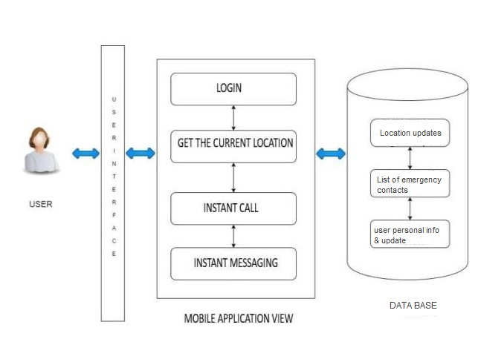
Fig. System Architecture

6. ERD DIAGRAM

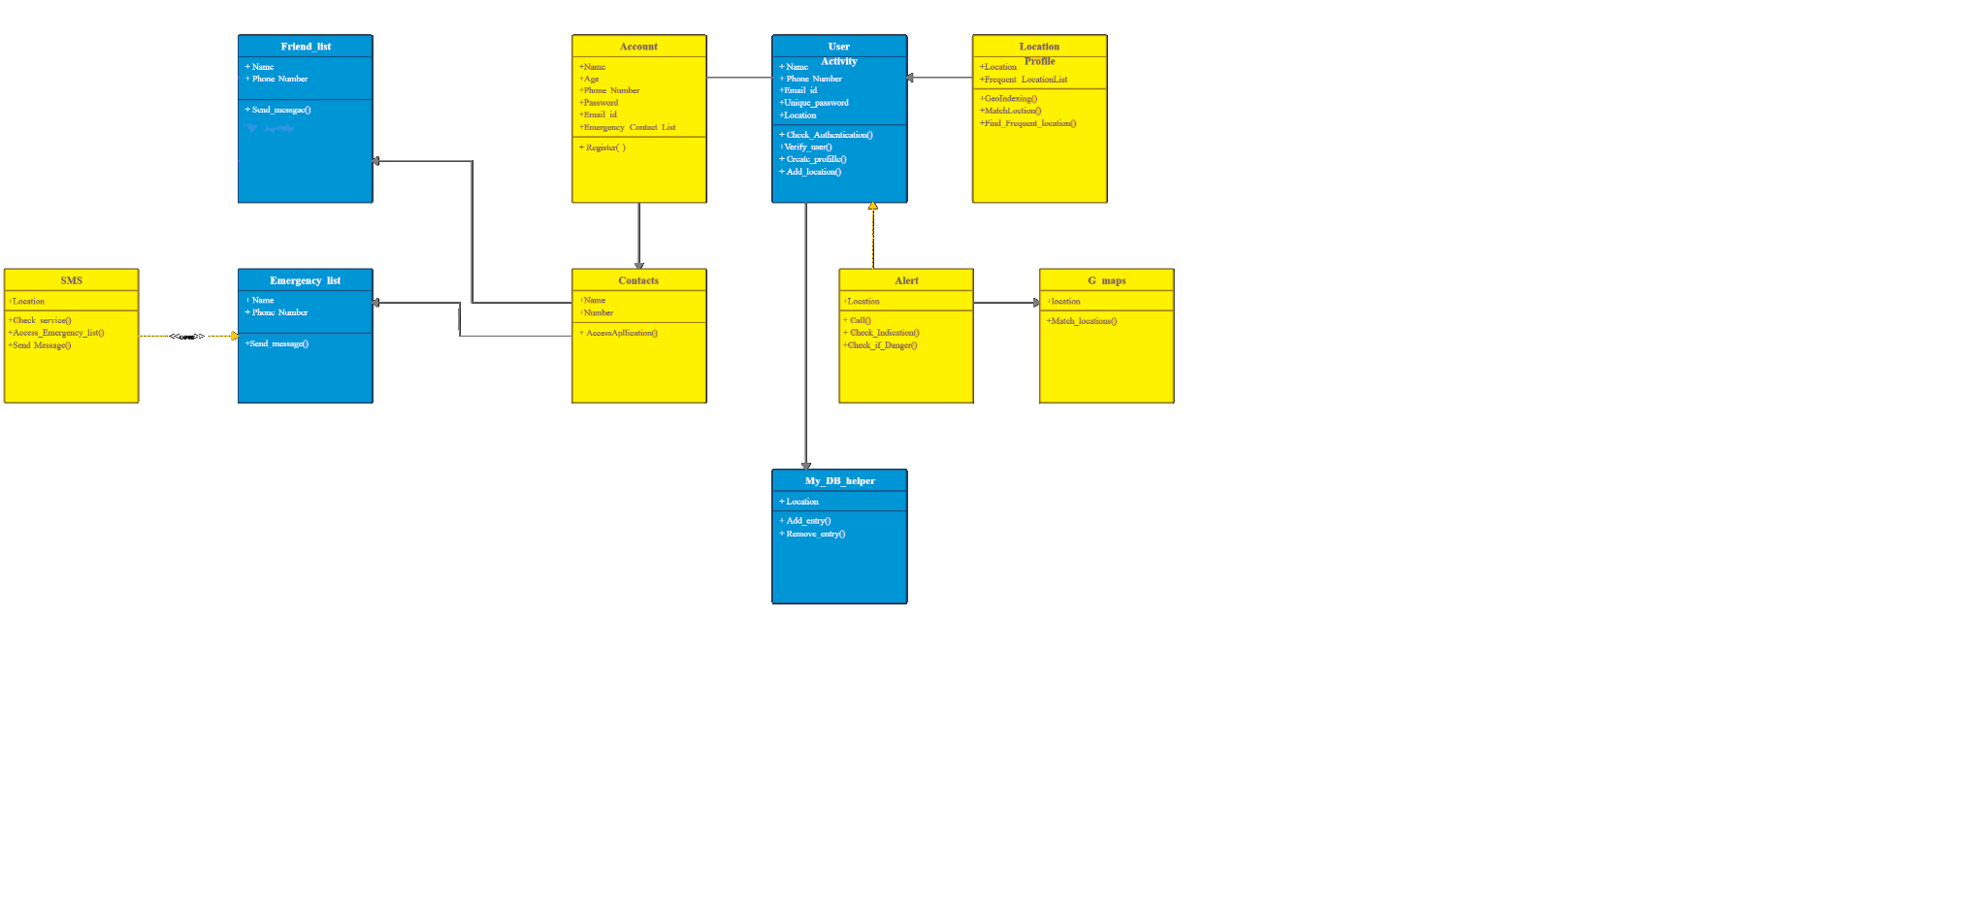
Fig. ERD

Components of ERD
 | ENTITIES | ALERT | LOCATION | G_MAPS | DB HELPER | SMS
 | ATTRIBUTES | LOCATION | LOCATION  FREQUENT LOCATION LIST | LOCATION | LOCATION | LOCATION
 | PURPOSE | CALL ()  CHECK_INDICATION ()  CHECK_IF_DANGER () | CHECK_AUTHENTICATION ()  VERIFY_USER ()  CREATE_PROFILE ()  ADD_LOCATION () | MATCH_LOCATION () | ADD_ENTRY ()  REMOVE_ENTRY () | CHECK_SERVICE ()  ACCESS_EMERGENCY_LIST ()  SEND_MESSAGE ()

- Alert checks if the danger button is pressed or not then either makes calls or sends sms to guardians.
- Location verify user info and add user location in database.
- Google maps provides the current location of the user.
- Databases add or remove the records of users.
- SMS checks internet connection and sends messages to guardians in the friend list if the danger button is pressed.

Components of ERD
 | ENTITIES | ACCOUNT | USER | CONTACTS | FRIEND  LIST | EMERGENCY  LIST
 | ATTRIBUTES | NAME  AGE  PASSWORD  PHONE NO  EMAIL  EMERGENCY CONTACT LIST | NAME  PHONE NO  PASSWORD  EMAIL  LOCATION | NAME  NUMBER | NAME  PHONE NO | NAME  PHONE NO
 | PURPOSE | REGISTER () | CHECK_AUTHENTICATION ()  VERIFY_USER ()  CREATE_PROFILE ()  ADD_LOCATION () | ACCESS_APPLICATION () | SEND_MESSAGE () | SEND_MESSAGE ()

Accounts will save the personal information of the user and perform the registration process.

User will check the authentication of entered data and add location.

Contacts will add the friends or guardians in the list.

Friends list contacts would be accessed and messages would be sent to them in case of emergency.

Emergency list contacts will be sent automatically by the app.

7. Data Flow Diagram (DFD)

User will add his/her personal info in the registration page which will be stored in the database.

SMS will be sent to contacts stored in the database when the danger button is pressed.

Ménage the contacts of guardians and store them in a database.

GPS will track the current location of the user in the database.
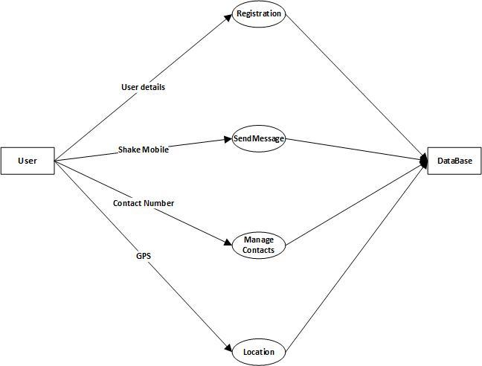
Fig. DFD

I. Level-0 DFD

Shows outline of the system models.

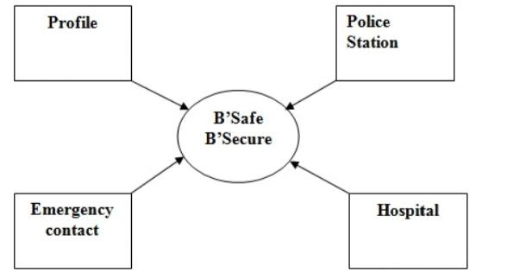
Fig. Level 0 DFD

II. Level-1 DFD

This differentiates the modules frontend and backend

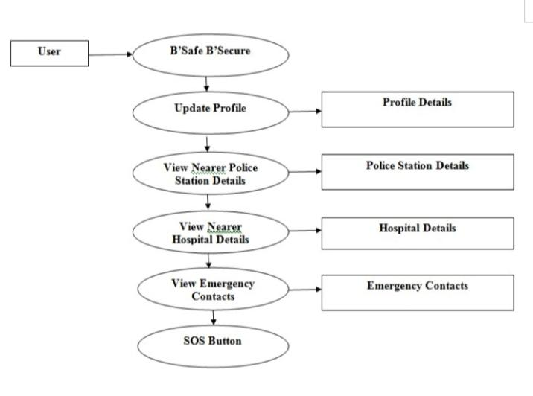
Fig. Level 1 DFD

8. CLASS DIAGRAM

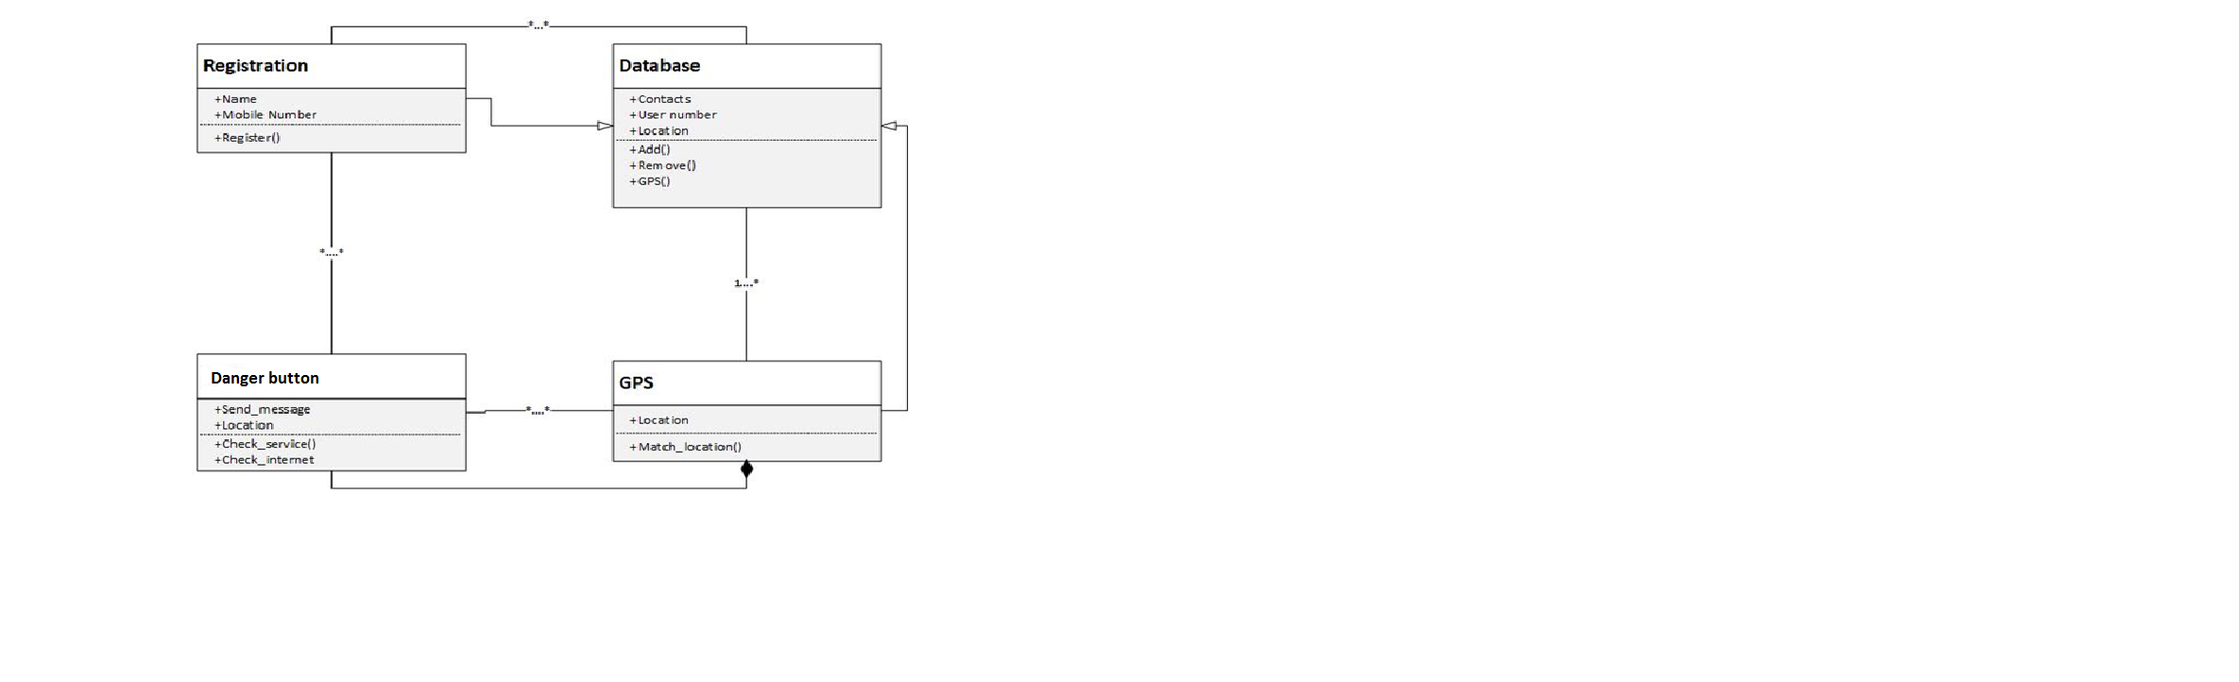
Fig. Class Diagram of Be Safe Be Secure

CLASS NAME | ATTRIBUTES | OPERATIONS
REGISTRATION | NAME  MOBILE NUMBER | REGISTER ()
DATABASE | USER_NAME  CONTACT  LOCATION | ADD ()  REMOVE ()  GPS ()
GPS | LOCATION | MATCH_LOCATION ()
DANGER BUTTON | LOCATION  SEND_MESSAGE | CHECK_INTERNET ()  CHECK_LOCATION ()

9. Sequence Diagram

The sequence of the executions within the system are in the following order:
• When the user registers their contact, they need to register their details along with emergency contact.
• When they have a problem, they need to press the SOS button so that an emergency message will be sent to the contacts along with the live location.
• Along with the pressing danger button they get the help on time. They can also further view their safe region.

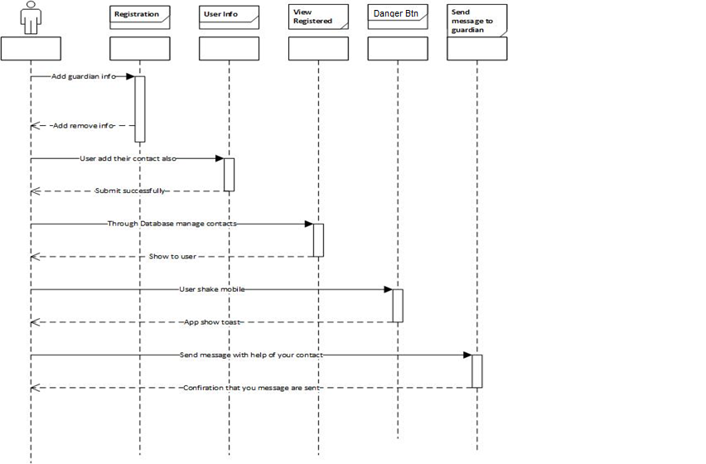
Fig. Sequence Diagram

10. Use Cases

10.1 Use Case Diagram

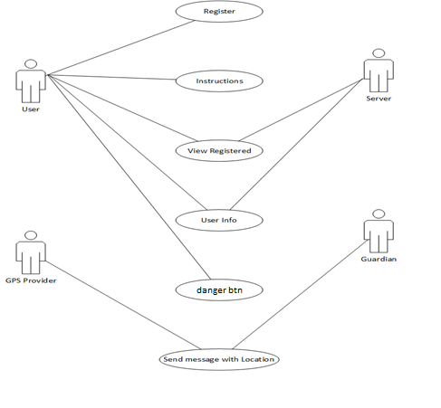
Fig. Use Case Diagram
10.2 Use Case Description
- Use Case User Registration:

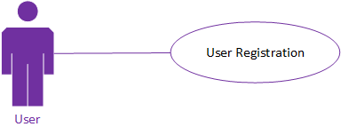

Use case ID | 01
Use case Name | User registration
Description | The user has to register himself/herself by adding the name, phone number, email and password
Primary Actor | User
Secondary Actor | System
Pre-Condition | Information provided by the user will be correct.  Internet connection is mandatory
Post-Condition | User should have to be, registered with the system successfully
Basic Flow | Action Actor | System Action
 | 1. The user enters the name, email, password, phone number and address,  2. User submits the information | 1. The system verifies the provided information
Alternate Flow | If the service seeker didn’t have an account and want to log _in into system, the system reminds him/her for creating an account

- Use Case User Login:

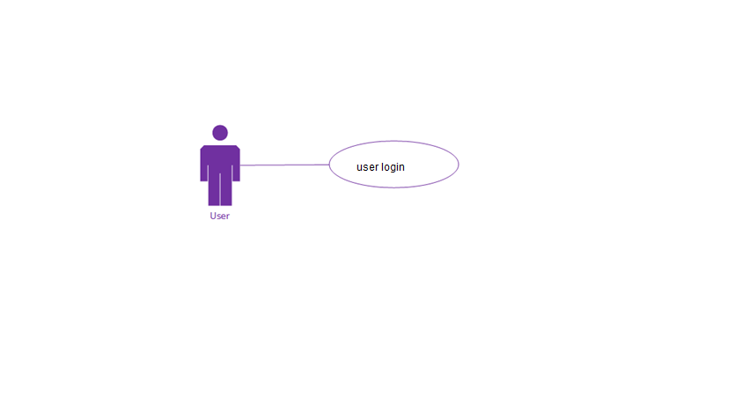

Use case ID | UC-2
Use case Name | User login
Description | The user wants to login his/her created account, then it is mandatory for the user to enter his/her required details i.e. name and password.
Primary Actor | User
Secondary Actor | system
Pre-Condition | Internet connection is mandatory.  Users must have an account.
Post-Condition | Users will have to access the system or login successfully.
Basic Flow | Action Actor | System Action
 | 1. User enters a name and password.  2. Press the login button to login with the system. | 1. The system verifies the name and password.  2. If the name and password is correct then, the system successfully logs the user.
Alternate Flow | If the user does not have an account and wants to login into the system, the system reminds him/her to create an account.

Use Case Guardian Registration:

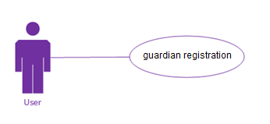
Use case ID | Uc_3
Use case Name | Friends list registration
Description | The user has to register himself/herself by adding the name, phone number, email and password.
Primary Actor | user
Secondary Actor | system
Pre-Condition | Information provided by the user will be correct.  Internet connection is mandatory.
Post-Condition | Users should have to be registered with the system successfully.
Basic Flow | Action Actor | System Action
 | 1. The user enters the name, email, password, phone number and address,  2. User submits the information. | 1. The system verifies the provided information.  2. If the information of the user is correctly inserted. Then, the system registers the user.  3. System displays registration successful messages.
Alternate Flow | If the information is not correct, the system shows a dialog box of error messages.

Use Case Danger Button:

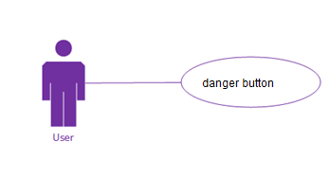
Use case ID | Uc_4
Use case Name | Danger button
Description | In case of emergency, the user will press the danger button and an alert message will be sent to the guardians in the friend list.
Primary Actor | user
Secondary Actor | system
Pre-Condition | Wi-Fi availability is mandatory.
Post-Condition | Send message to guardian is post condition
Basic Flow | Action Actor | System Action
 | Pressing the danger button | Send SMS to the guardian stored in the database and track location through GPS.
Alternate Flow | If Wi-Fi is not available, the system will show a dialogue box showing no internet connection.

Use Case Updating Info

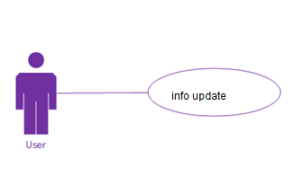
Use case ID | Uc_5
Use case Name | Updating info
Description | Users can change or delete the information of his/her guardians and can also change his/her personal information.
Primary Actor | user
Secondary Actor | system
Pre-Condition | Users must have an account of his/her self as well as the account of his/ her guardians.
Post-Condition | User & guardian records will be updated after providing updated information.
Basic Flow | Action Actor | System Action
 | User entered the updated information. | System verifies the information and saves it in the records.
Alternate Flow | If Wi-Fi is not available, the system will not save the updated activity.

11. Graphical User Interfaces

When the user opens the app, the splash screen interface will appear on screen.

<User Interface Id: Title>
Interface Id. |  | 01
Snapshot
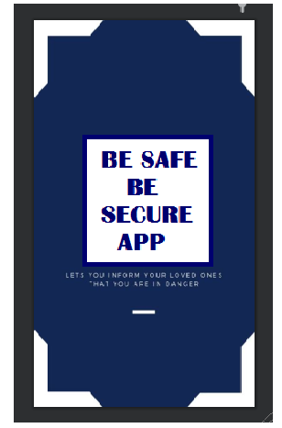
Data dictionary reference
Label | Data dictionary identifier
 | Splash screen

<User Interface Id: Title>
Interface Id. |  | 02
Use case Reference |  | Enter and Update info (profile)
Snapshot
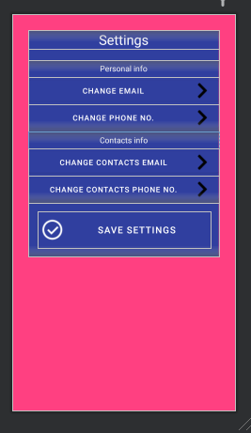

Data dictionary reference
Label | Data dictionary identifier
 | SETTINGS
 | Personal info
 | Contacts info
In the Information profile, users can view all the settings related to personal and guardians’ information .Users can also update the information here.

<User Interface Id: Title>
Interface Id. |  | 03
Use case Reference |  | Danger button
Snapshot
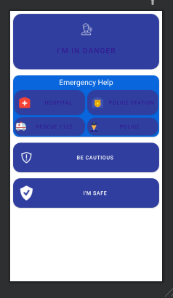

Data dictionary reference
Label | Data dictionary identifier
 | Danger button
 | hospitals
 | Police stations
 | I AM SAFE! message
 | Be cautious! instruction
In case of emergency, the user will press the danger button and an alert message will be sent to the guardians in the friends list. phone numbers and location of nearby police stations and hospitals will be messaged to the user.

<User Interface Id: Title>
Interface Id. |  | 04
Use case Reference |  | User information
Snapshot
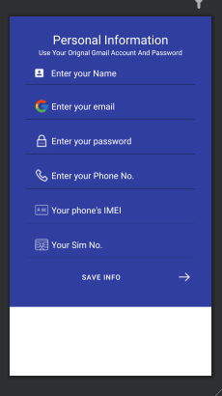

Data dictionary reference
Label | Data dictionary identifier
 | name
 | email
 | password
 | Phone no
Users save his/her personal information in the database of the system.

<User Interface Id: Title>
Interface Id. |  | 05
Use case Reference |  | Friend lists
Snapshot
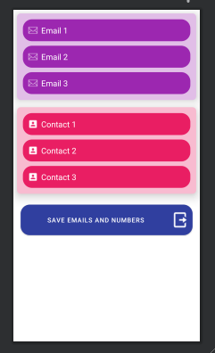

Data dictionary reference
Label | Data dictionary identifier
 | contacts
 | emails
List of contacts and emails of guardians saved in the database.

<User Interface Id: Title>
Interface Id. |  | 06
Use case Reference |  | Emails of guardians
Snapshot
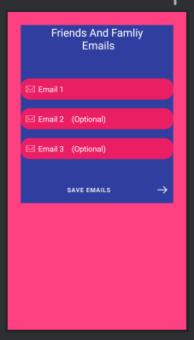

Data dictionary reference
Label | Data dictionary identifier
 | Email 1
 | Email 2 (optional)
 | Email 3 (optional)
 | SAVE Emails
Emails of friends and family members you want to contact in an emergency.

<User Interface Id: Title>
Interface Id. |  | 06
Use case Reference |  | Contact of guardians
Snapshot
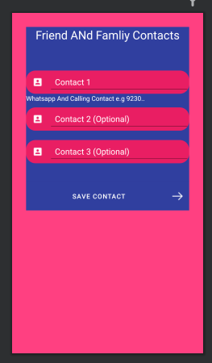
Data dictionary reference
Label | Data dictionary identifier
 | Contact 1
 | Contact 2 (optional)
 | Contact 3 (optional)
 | Save contacts
Save contacts of guardians in the database.

12. CONSTRUCTIVE COST MODEL (COCOMO)

12.1 INTRODUCTION:

Public’s safety is a big concern which has been the most important topic till date. People's safety matters a lot whether at home, outside the home or working place. Most of the people these days carry their smartphone with them, so it is necessary to have at least one of the personal safety apps installed. Such a security app for people will definitely facilitate in a way or the opposite.

12.2 ABSTRACT:
This paper provides a real sort of applying COCOMO as an estimation technique for the required software development effort in a safety-critical software application project. The main goal and contribution of the case study is to support the research on software effort estimation and to provide software practitioners with useful data based on a real project. The alternatives obtained from results will be used for future work in order to increase the effort estimation accuracy in safety-critical software projects.

12.3 COCOMO CLASS:

Our proposed system lies under the ORGANIC class of COCOMO.
As the team size required for our proposed system is adequately small, the problem is well understood and has been solved in the past and also the team members have a nominal experience regarding the problem.

12.4 STAGES OF COCOMO:

Three levels of the model:

- Basic
- Intermediate
- Detailed

- BASIC COCOMO LEVEL:

The first level, Basic COCOMO can be used for quick and slightly rough calculations of Software Costs. Its accuracy is somewhat restricted due to the absence of sufficient factor considerations.

Software Projects |  | Constant values
Software Projects | a | b | c | d
Organic | 2.4 | 1.05 | 2.5 | 0.38
Semi Detached | 3.0 | 1.12 | 2.5 | 0.35
Embedded | 3.6 | 1.20 | 2.5 | 0.32
Fig. Basic Level Estimation Values 1

INPUTS:
PROJECT MODE: | ORGANIC
PROJECT SIZE: | SMALL
OUTPUT:
EFFORT: | 2740028.08309
DURATION: | 7075760.12034
AVERAGE STAFFING: | 0.3872415170

BASIC COCOMO LEVEL FORMULA
- EFFORT ESTIMATION
a _{b} (KLOC) ^{b}_{b}
- DURATION
c_{b} (EFFORT) ^{d}_{b}
- AVERAGE STAFFING
E/D
- Our proposed system LOC approximation is 400K LOC.
LOC: lines of codes.
TIME REQUIRED TO BUILD THE APP: 4 Months
APPROXIMATE CODE LINES: 12 Million
LOC: 12 Million / 4 Months
LOC: 400K per hour metrix.

EFFORT ESTIMATION | = a _{b} (KLOC) ^{b}_{b}
 | = 2.4 (400K)^{1.05}
 | =2740028.08309 per hour metrix.

DURATION | = c _{b} (EFFORT) ^{d}_{b}
 | = 2.5 (2740028.08309)^{0.38}
 | =7075760.12034 per hour matrix.

AVERAGE STAFFING | = EFFORT/DURATION
 | = 2740028.08309/7075760.12034
 | = 0.3872415170

- INTERMEDIATE COCOMO LEVEL:
The Intermediate COCOMO model computes software development effort as a function of program size and a set of "cost drivers" that include subjective assessments of product, hardware, personnel and project attributes.

Software Projects |  | Constant values
Software Projects | a | b | c | d
Organic | 3.2 | 1.05 | 2.5 | 0.38
Semi Detached | 3.0 | 1.12 | 2.5 | 0.35
Embedded | 2.8 | 1.20 | 2.5 | 0.32
FIG. INTERMEDIATE LEVEL ESTIMATION VALUE 1

INPUT:
PROJECT MODE: | ORGANIC
PROJECT SIZE: | SMALL
OUTPUT:
EFFORT: | 2740028.08309

INTERMEDIATE COCOMO LEVEL FORMULA
EFFORT ESTIMATION
a_{i} (KLOC) ^{b}_{i}
Our proposed system LOC approximation is 400 LOC.
LOC: lines of codes.
TIME REQUIRED TO BUILD THE APP: 4 Months
APPROXIMATE CODE LINES: 12 Million
LOC: 12 Million / 4 Months
LOC: 400K per hour metrix.

EFFORT ESTIMATION | = a _{i} (KLOC) ^{b}_{i}
 | = 3.2 (400K)^{1.05}
 | = 2740028.08309 per hour matrix

13. References

Ref. No. | Document Title | Date of Release/ Publication | Document Source
PGBH01-2003-Proposal | Project Proposal | JAN 10, 2021 | BE SAFE BE SECURE  File compiled by group members.

